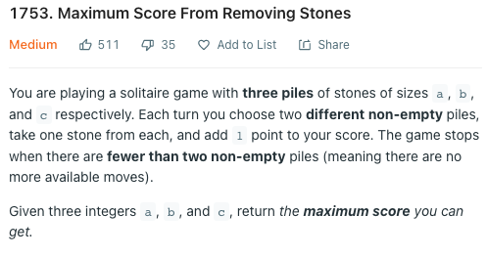

Idea :

When the longest pile still alive, we can always get the score from removing a stone from the longest pile with a stone from another pile -> That time, stone in the another two score one point each

When the longest pile die, we have to remove the stones from each of the other piles ->   
That time, stone in the another two score one point for pair each (0.5 each stone)

Therefore, we would try to exhaust all the stones from the longest pile by matching the stone with the 2-second highest pile at that time : target (= max(a,b,c))  
If it cannot which would be the case (a+b+c – 2\*target < 0)   
-> then the max score would be (a+b+c – target) (i.e. the total amount of another two piles)

If we exhaust all the stones in longest pile : we get score = target  
Then we would start to pick the stones from each of the remaining piles floor((a+b+c-2 \* target) / 2)  
Then the max score would be target + floor((a+b+c-2 \* target) / 2)